COSEE-ALASKA Teacher Academy: The Bering Sea Workshop
By Andrea Anderson, Ph.D.,
COSEE-Alaska Evaluator
Event Date: October 13-20, 2010

Context
COSEE Alaska: People, Oceans and Climate Change is one of 12 Centers for Ocean Science Education Excellence in the United States. The core mission for these centers is to provide support for ocean scientists to communicate with the public and to increase ocean science awareness and literacy among the citizens.
COSEE Alaska seeks to help the public better understand the ocean environment and ecosystems of Alaska, ocean climate change, and to illustrate the way western science integrates with indigenous knowledge of the local environment to build a more complete understanding of climate change.

Event Description
In October 2010, COSEE Alaska co-sponsored a workshop with the North Pacific Research Board (NPRB), Arctic Research Consortium of the US (ARCUS), NOAA and NSF, to bring together teachers who have been at sea, with the BEST-BSIERP project, and with teachers from local communities. The purpose was to create a web-based collection of activities, lesson plans, personal reflections and photos that could be used by any teacher to educate students about the Bering Sea Ecosystem.
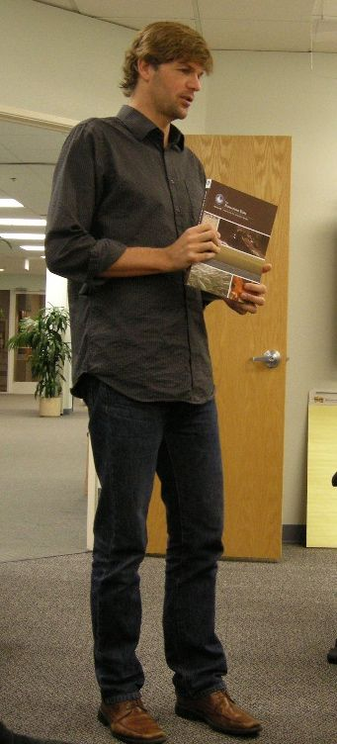
The five-day workshop served nine teachers from Alaska and around the country. Several of the teachers had been at sea with the ARCUS program and had worked with some of the scientists directly participating in this workshop. Other teachers came from local Bering Sea communities and brought the perspectives of working within the Alaska Native cultures.
Ten scientists also participated; six of the scientists were present for most or part of the workshop, including the scientist (left) who directs the Bering Sea Project for the NPRB. Each participating scientists represented one or more aspects of the ecosystem view of the Bering Sea.
George Matsumoto, a scientist working with MBARI, facilitated the workshop, bringing with him a deep set of experiences with similar EARTH workshops. (See http://www.mbari.org/earth/ for additional details.)

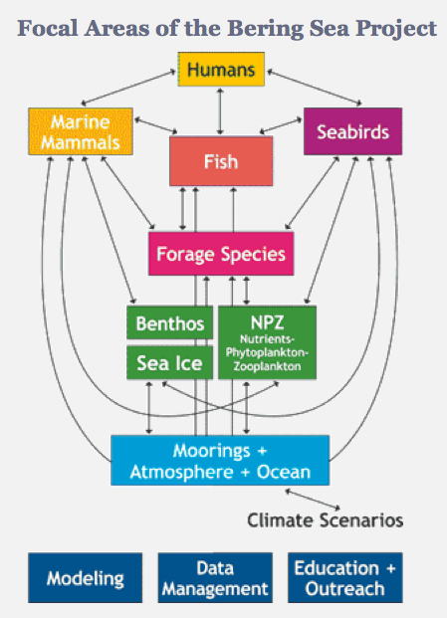
The workshop program included presentations by participating teachers and an overview of the Bering Sea research with specific topic presentations that reflect the encompassing perspective of the ecosystem. The image that helped frame the workshop was the one that guides the Bering Sea ecosystem research.
The intent of the workshop was to have teachers learn from scientists, and either individually or in groups, create new lessons or activities for classroom use. Both the earlier created lessons and the new items from the workshop were to be hosted on a Bering Sea Website for educators.
Both the participant list and the program are included in the Appendix.

Evaluation Methodology
The purpose of this evaluation was three-fold:
- To gather formative evaluation data in order to monitor and adjust program elements during the workshop.
- To understand the impact of this workshop on the teachers’ attitudes and capacities to develop and include Bering Sea data in their teaching and to better understand the quality and durability of relationships (with scientists and each other) that derive from workshop interactions
- To understand the impact on scientists of engaging in this kind of broader impact activity.
Underlying the entire framework for this workshop is the effort to introduce traditional ecological knowledge and place-based understandings within the research and teaching endeavors.
Participants responded daily to an online survey that asked questions about concerns, what they particularly appreciated about the day’s event, and suggestions they might offer. We wanted to know from teachers whether they felt they were gaining the scientific information they needed in order to produce lessons or activities about the Bering Sea. We also asked what scientists hoped teachers would be able to use from the session.
At the end of the workshop we surveyed teachers about each presentation—whether it was interesting, useful, and if it could be shared with students. We also asked specifics about the quality of the workshop and for recommendations for future workshops. Informal interviews took place throughput the workshop to capture teachers’ views of the value of such a workshop.
Following each scientist’s presentation he or she was asked to respond to a set of 5 questions given in an open-ended interview format. The underlying purpose was to better understand the impact of the workshop on scientists’ views of engaging with Broader Impacts. The interviews we were able to conduct were recorded, transcribed and analyzed. It should be noted that since not all scientists were physically at the workshop, not everyone had this particular opportunity.

Summary of Findings
The workshop was highly successful in bringing together educators from across the United States to work with teachers from the Bering Sea Communities. All the educators had the opportunity to learn from and work with scientists deeply connected with the Bering Sea Ecosystem research program.
Teachers collaboratively produced a number of products there were able to post online for use by others. They were aided—deeply supported—in this process by the presence of scientists who willingly shared their research or, in some cases, found the resources teachers needed. The reciprocal benefit of the teacher-scientist interaction was reflected in comments from scientists and teachers alike. It may be the signature aspect of this workshop.

Results

Developing relationships between and among scientist and educators was a significant outcome from the workshop
A most significant aspect of the workshop was the development and nurturing of relationships among educators and with scientists. Several teachers had experienced being at sea with scientists, and valued deeply the respectful, collegial relationships that emerged from that experience and which translated to the workshop. Teachers also valued the opportunity to connect with other scientists doing Bering Sea research as it contributed to their deeper understanding of the science. Finally, the ability to meet and share with other educators holding equal passion about the area and the science-focus was very important. While the product was important to participants, the process and relationships were more significant.
Teachers’ comments in response to the question “what was the most significant part of the workshop for you” illustrate the point.
CONTINUED networking with scientists in the field

Being able to create new collaborations with my Alaskan teacher friends.

Bouncing ideas off of teachers who have been on the Healy!!! Having ARCUS, MBARI, NPRB staff available to help locate resources; having to develop a formal lesson plan.

Networking with teachers and researchers in person, making contacts, learning new ideas to bring into my classroom.

That so many people are involved in studying the different aspects of the Bering sea and the amount of data that has been collected.

The amount and depth of the lessons that came out of it- it was an amazing amount of work out of a short period of time.

Sharing and interacting with others

The coordination and blending of science professionals and in the field professional educators was perfect. The presentations were well designed and understandable so that there will be increased opportunity for application in the classroom

In parallel, the scientists were asked about what surprised them in the workshop. Most sidestepped that question and shared their sense of admiration and respect for the teachers. Overall scientists expressed a surprise and pleasure at the quality of teacher thinking and engagement, the questions they were asking, and how they were making sense of the topics. The following comments reflect the general view.
They are thinking about things in interesting and creative ways, which is terrific and really great to see. So I'm thrilled to be able to have a little insight into the way they look at things. And delighted there are people with this level of enthusiasm and commitment, interested in the types of research that I and others in the Bering Sea project do, and finding ways to make that compelling and interesting for students. Cause that is a tremendous skill and a lot of hard work goes into it and I have a great deal of respect for that.
I had high expectations for the teachers and they lived up to them, which that they were engaged and interested in thinking about the topic in creative ways. Paying attention to what just seems like from the agenda, like an incredibly busy schedule. Starting at 8 in the morning and going until after dinner. The energy level was still there, still very high.
What surprised me, and maybe it shouldn't have - but the teachers presentations were a whole lot more engaging than the scientists presentations. I don't know if that is the reason why we have each chosen our respective fields or if there is something more than that. That was pretty interesting to see that the teachers presentations were a whole lot more fun to be in. Maybe that's because I don't get to see talks like that very much. They were a lot fresher and new to me.
In general through this workshop I have been very surprised at how ready teachers are to deliver pretty sophisticated messages about nutrients, about benthic cycles. Pretty sophisticated stuff; pretty detailed. And it's not just our friend the sea otter. That has been a surprise for me in general —a really pleasant surprise. Because that is really what our project - this Bering Sea project - is all about. It is about bringing the details together into an integrated story, but not losing track of the details.
But it is fun to hear people go "oh, aha, yeah okay I get that." So that was really good to see that people were understanding (sic) at least some of the stuff that I was talking about during the presentation.

Scientists felt the workshop promoted a better understanding of how science is conducted.
While the aim of the workshop was to help teachers and their students with specific science content, an equally important outcome was the impact on the participating scientists. Some scientists and educators reconnected after collaborating during “Teacher at Sea” voyages. Their feelings of friendship and regard were obvious. But for a majority of the scientists present, the workshop was a first time interaction with these teachers.
We were curious about what the scientists thought of the workshop and what impact it might have on their thinking about engaging in and achieving “broader impacts.” Following individual presentations, scientists were asked to respond to a series of 5 questions in a taped response:
- What kinds of things did you consider in preparing for your talk?
- How was preparing for this talk similar to and different from preparing a presentation for scientists
- How much and in what ways did you consider what teachers might do with the presentation?
- What do you hope teachers will do with the topic? What would success look like to you?
- Was there anything from the workshop that surprised you?
Scientists used the interview questions to reflect on the way science is conducted and their deep hopes that teachers might convey to students more the process of science and not focus on the products of science. Scientists said they hoped teachers and students would be enthused about science, be inspired by science, and begin seeing it as a puzzle to investigate rather than a set of static findings. The quotes below are reflective of these perspectives.
In this particular case I think is more that message of the need for multidisciplinary, multi-institutional engagement that it requires to answers these big ecosystem questions…to be able to convey, hopefully better, what it takes to actually collect this information. Become part of this big effort and make a difference...which is actually, really (the) fun part of science to do.
It's kind of tough with this research that is underway that hasn't been through the full review process. The process of scientific exploration often goes down a lot of corridors and you wind up opening lots of doors off these corridors; and most of these doors wind up being dead ends. You come back out and it's sort of laborious iterative process, where every once in awhile you get a door that opens up a whole new set of pathways. And that's really exciting.
When you are in the middle of the research and sending it out you don't always - you don't know which of the paths are going to be the proper ones to take. It's a little disconcerting to try to put yourself out on the line. Because something that you say right now you might reconsider, look at from a bunch of different angles, and come to the conclusion three or four months from now that that wasn't the right way to think about the problem. There is actually a better way to think about it. What I hope teachers would do - I hope that they take these presentations with a grain of salt. Because it’s the ugly portion of sausage making when you are right there at the time the research is being done. A lot of stuff gets thrown out. When it is all said and done the peer review science is a good thing. But you can have a whole lot of false starts as you are going on your way there.
My goal with the presentation was more to give them a bigger context, because we often throw them into results. They go to websites - they see an end product - and they don't necessarily know or understand. Like the National Geographic movie, or Planet Earth thing that you see in one hour video, you see all the cool things that come out…you see the most amazing things that took them five to ten years to actually put together… and then the kids get this vision of what it is to be a scientist that is really quite different from what it really is. And that goes for anybody really. Where that (the outcome) comes from or what it takes to do so. (Science) is a lot of grunt work and lot of preparation and lot of planning, a lot of thinking and a lot of crunching numbers...and a lot of fun when you are out there collecting data and actually figuring out what the numbers mean when you are back.

It is not only the end result…There is a lot of moving parts and pieces so people should learn to acknowledge all the stuff that is involved in order to do so and I was hoping they would get some of that. I think that is important. And it is important in terms of inspiring young people as well who are going to become scientists.

Scientists offered specific insights about how best to prepare for working with teachers (or the public, or students).
Scientists noted that preparing for work with teachers was actually similar to preparing presentations for other scientists that are not working in their particular field. From their interview comments we were able to distill key lessons—insights—that might be useful for others scientists in thinking about and preparing for education and outreach to new audiences:
  - Avoid jargon, technical language and excessive detail
I could see that it's really easy to get too deep into detail with these science talks for educators. The main thing that I considered in preparing my talk was keeping it simple. Keeping it lively. Not buried into the weeds.

Really minimizing jargon because speaking with scientists, jargon has a role and it can be shorthand to communicate more easily. With this group I wanted to be careful that I wasn't getting into the jargon or the details too much.

  - Figure out who the audience is and speak to them; Try to tell a story that engages them from their particular interest area.
the most important part for me is always consider the audience. And what level of knowledge they already have on a given subject and what other things they have done that I can link to. And I usually always look for synergy, so when I talk to or go to classrooms for example, I try to find out what they have already studied so I can link up to what is already known to them

Each presentation sort of tells a story and it can be - it takes a lot of work to grab snapshots of different people's presentations and make a new cohesive story out of it.

  - Recognize that most audience members are less interested in the nitty-gritty details of the research and more interested in the results.
I may not be particularly interested in the nitty gritty details of exactly what kind of mesh and net they used for the plankton tow. I trust that those guys know what they are doing and they have done it right. The question I'm curious about is what kind of results did they get. So it’s similarly talking with the teachers - some aspects and methods may be of interest to them, but I was expecting they would be less interested in methods for their own sake than in the results and then perhaps some talk about the methods that get you there.

  - Connect to the human element so that people see how and why the research matters.
I think the people connection, obviously to me is very important. I think it does help show - I think in some ways a useful entry point for students to think about the people who are there, what they do, what kind of information you would want to have if you were a resident in the area.

Teachers valued the contributions of each scientist; their responses point out a deepening understanding of how parts of the ecosystem are integrated.
We asked teachers to rate the different presentations—thinking we might ferret out topics in need of additional support (or even, perhaps, a different presenter). Across the board the teachers found each topic interesting and useful, although some wondered whether the content might be made appropriate for their students.
The graphs in this section demonstrate that each presentation was highly regarded. Coupled with relatively little variance in the average scores, it is difficult to interpret any one topical area having more impact on teachers than another or that any topic needs additional training support .
The scores seem to affirm not only the skills and capacities of the individual presenters, but also the teachers’ recognition that each presentation was a critical puzzle piece for an integrated understanding of the Bering Sea as a complex ecosystem.
As one scientist observed, the teachers’ response to each of the presentations seemed to underscore their deepening understanding of how parts of the ecosystem work together to make the functional whole.
The three graphs on this page are from the introduction to the Bering Sea project, from the perspectives of the NPRB – BEST scientists and the NSF – BSIERP scientists.

Other scientists focused on the critical dimensions of researching this Bering Sea ecosystem and in understanding climate change: the water—chemistry, currents, ice—benthic organisms and nutrients, phyto- and zooplankton, megafauna, the computer modeling of data, and the human element. These graphs are presented below.

Only one rating suggests that teachers might have difficulty using the topic with their students: modeling the impacts of climate change. Given the range of teachers—from elementary to secondary school —this finding is not surprising. It might however, suggest that modeling science is a possible new professional development course.

Learning about and appreciating Alaska Native cultures in the context of the Bering Sea ecosystem was a major theme of the workshop.
An important dimension of this workshop was that local teachers, from Bering Sea communities, were able to link with teachers from the Lower 48. Throughout the workshop teachers talked and enlarged their understanding of Alaska Native students’ experience the realities of the Bering Sea.
Supporting the integration of both traditional ecological knowledge and western research science, teachers had a special viewing and tour opportunity at the Anchorage Museum with Curator, Aaron Crowell. His commentaries and specific knowledge of Alaska Native added depth to one of the workshop’s key goals: to help teachers understand the human dimension of the ecosystem and to facilitate the integration of traditional ecological knowledge with what western science understands about the Bering Sea ecosystem.
Teachers utilized the experience to inform their lesson designs and it seemed to further enhance the relationships formed among the teachers. The high scores on the graph to the right indicate the value the teachers put on this experience.

The workshop produced lessons and other products of value and use to the educators.
Teachers worked collaboratively to create new lessons based on the presentations and with the support of the participating scientists. The teachers presented lessons to each other on the final day of the workshop. In the end of workshop survey we asked teachers to indicate which lessons they were likely to use. The following table shows that all lessons have some likelihood of being used, with some being rated as “absolutely will use.”

From the post workshop presentations, which lessons are you likely to use?
Answer Options | Not likely | Somewhat likely | Very likely | Absolutely will use | Average
Ice (Maggie and Tonia) | 0 | 1 | 4 | 2 | 3.14
Salty or Not (Deanna) | 0 | 0 | 4 | 3 | 3.43
Intro to the Bering Sea (Jillian, Francis, Emily) | 0 | 2 | 5 | 0 | 2.71
Ssss'now Seals (Paul and Maggie) | 0 | 4 | 1 | 2 | 2.71
Bering Sea Buffet (Samantha) | 1 | 1 | 3 | 2 | 2.86

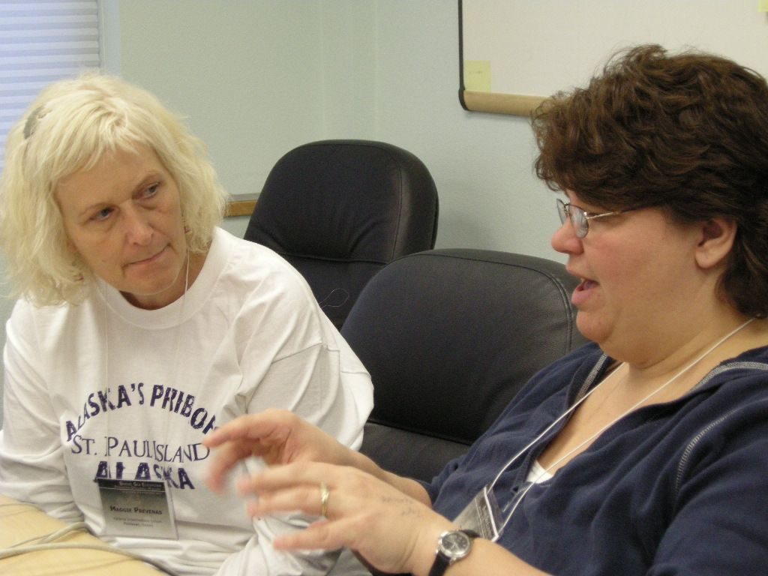
One of the ways we studied relationship building was to ask participants to complete a social networking “map.” We examined what topics teachers were talking about with each other. We wanted to know who was talking with whom. We found participants spent an equal amount of time discussing personal interests, science content and ways of teaching the content they were learning. We found that a very important theme woven through the presentations, the curriculum and the conversations was how to integrate western science with the traditional ecological knowledge of Alaska Natives in the Bering Sea ecosystem. Teachers worked to incorporate this understanding in meaningful ways for their students.
The photo included here represents the very special connections that were made. Tonia (right) is a teacher working with Alaska Native students in the Pribilof Islands. She is making plans with Maggie (left) who is a teacher of middle school students in Hawaii. Together the women have organized student exchanges and connections, resulting in visits of students to each other’s community.

Participants provide specific insights about how to make such workshops effective; gave thanks and kudos to staff and scientists.
At the end of each day participants were asked to respond to an online survey that asked them what concerns they had, what they liked about the workshop, and what suggestions they might offer for the following day. While some comments were specific to the day’s events, others provide direction or guidance for designing future, similar workshops. These findings are included here:
- Intermixing teacher and scientist presentations was effective – kept interest high with a lively flow of doing and dialog
- Allowing discussion opportunities throughout the sessions, instead of the end of day
- Learning about the resources, ideas for collaboration, and curriculum and having them made available online in a just-in-time fashion
- Using visualizations that help tell the story
- The opportunities for networking with each other—meeting others like self and finding the essential connections.
- A comfortable, safe, respectful environment; being valued for expertise whether as a scientist or an educator
- Recognition of basic creature comforts (food and breaks) that permit people to engage for extended periods of time.
- Time for reflection—particularly where some of the content is new and requires accommodation and assimilation of the ideas.
- Avoidance of jargon by both scientists and educators facilitated understanding on both sides of the effort.
- Having scientists physically present, able to confer with teachers one on one, is a major aspect contributing to success. Email is a useful tool, but it does not substitute for direct one-on-one conversations

Overall the teachers rated the workshop logistics and components very high. In open-ended comments teachers expressed their appreciation for the workshop, the staff and the scientists who were there and so supportive and offered suggestions for improving the next COSEE Academy. The following table illustrates the ratings given to different dimensions of the event and is followed by comments from teachers.

Final Evaluation of Bering Sea Teacher Workshop
Answer Options | Poor | Average | Good | Very Good | Excellent
Level of organization | 0 | 0 | 0 | 0 | 7
Availability of NPRB, COSEE, MBARI, and ARCUS staff | 0 | 0 | 0 | 0 | 7
Quality of facilitator | 0 | 0 | 0 | 0 | 7
Level of enjoyment/fun | 0 | 0 | 2 | 1 | 4
Quality of presenters | 0 | 0 | 1 | 3 | 3
Variety of activities | 0 | 0 | 3 | 2 | 2
Bering Sea Workshop (Overall) | 0 | 0 | 1 | 2 | 4
N=7
Teachers comments:
Variety of activities…The variety of the days made them pass all to quick. A huge thanks, from Paul from Emo.

Everything from this workshop- the researchers and teachers, quality of resources available…A chance for teachers to talk and figure out how the new content fits into their Standard Course of study and units for their grade level…The experts were very informative and well versed in their expertise. The dinners, lunches, hotel, etc were well planned.

George was an excellent moderator. I pictured George as someone who spoke softly yet carried a big stick. He kept things moving quite well plus was quite informative. I was impressed with his computer knowledge.

Conclusions and Recommendations
This workshop grew out of key initial opportunities for the teachers—the ARCUS Teacher at Sea program— and built on the MBARI EARTH workshop model to create an outstanding program in which educators from across the country could collaborate with teachers of Alaskan Native youth and scientists working in the Bering Sea. It also relied on significant contributions from the North Pacific Research Board whose researchers are building the knowledge base for the Bering Sea ecosystem. The combined efforts of key partners made this workshop successful.
In teacher professional development it is far more typical to have scientists drop in, deliver a lecture and depart. Critical to the success of this effort was the ongoing presence and active contributions of at least six scientists who were present every day. Teachers commented frequently about the significant help the present scientists were in answering questions, providing resources, giving guidance, and offering suggestions.
Another aspect of this workshop that contributed to success was the careful selection of participating teachers. Their passion, commitment and productivity were evident from the outset. Equally powerful was the teachers’ awareness of and willingness to understand and include the perspectives of indigenous cultures influenced by the Bering Sea (and Pacific Ocean) ecosystem. Of particular note was the effort among teachers to link together and support indigenous student populations, whether from the Bering Sea, Arizona or Hawaii.
The model of this workshop is one that could be disseminated to other COSEEs as it achieved three essential outcomes that are relevant to the COSEE mission:
            - Scientists were supported in doing and thinking about education and outreach as it related to their specific research areas.
            - Ocean science research was communicated and made meaningful to the participating teachers, and through their lesson development to other educators who may access the website.
            - The potential for “broadening participation” in the sciences was enhanced with the education support provided indigenous student populations located in various communities.
A final comment about this model of professional development is that the focus was the ecosystem and the intellectual frame was how components combine to be a system. The scientists at BEST-BSIERP are conducting their research within the frame “ecosystem” and it was important to convey the same intellectual framework to the teachers. Teachers gained specific knowledge about the core components of oceanography (e.g., chemical, physical, geological and biological sciences) and more meaningfully, how the pieces are integrated. Further the human dimension was fully embedded in the structure.
The following recommendations grow out of this COSEE-Alaska event.

COSEE-Alaska might consider other similar ecosystem-wide workshops for teachers.
COSEE Alaska is already planning for a similar event to be held in June 2011 in Southeast Alaska. Additional opportunities exist for students and teachers in the Arctic region.

COSEE-Alaska might consider disseminating this workshop model to other COSEEs in the network.
The workshop, constructed around “ecosystems,” provides a different kind of lens for professional development of teachers. It engages them in learning about key content areas, but by using an ecosystem frame, it helps them construct understanding in a more meaningful way. The model would allow any other COSEE to address conditions in their own local ecosystems.

COSEE-Alaska might consider a follow up engagement with the participating teachers.
The costs of in-person workshops might prohibit a face-to-face gathering of the participants. However, an online conference might further enhance the understandings and communal sharing initiated through this workshop. In addition, COSEE Alaska might further investigate what teachers have done subsequent to the workshop; what lessons were taught, what exchanges occurred, what further contacts with scientists were made and what impact has the experience had on students.

COSEE-Alaska might consider how to share the products of this workshop on a broader basis.
The lessons and other products developed from the workshop ought to be a part of the COSEE Alaska website and disseminated broadly through meetings such as the National Marine Educators Association.

Appendix

Bering Sea Ecosystem Professional Development Workshop
Participant List: Teachers
Samantha Dassler Barlow
Rogers-Herr Middle School
911 W. Cornwallis Rd.
Durham, NC 27707
P: 919-560-3970
missdassler@yahoo.com
C: 252-341-9099

Deb Endicott
Curriculum Specialist
Southwest Region School District
574 Kenny Wren Rd.
P.O. Box 90
Dillingham, AK 99576
P: (907) 842-1302
dendicott@swrsd.org

Todd Hindman
Anvil City Science Academy
PO Box 131
Nome, Alaska 99762
P: 907-443-6207
thindman@nomeschools.com
C: 907-443-3123

Tonia Kushin
St. Paul School, Pribilof S.D.
905 Tolstoi Road
PO Box 905
St. Paul Island, AK 99660
P: 907-546-2388
kushint@psb-k.12.org

Paul Lukosi
Emmonak School
100 School Rd
Emmonak, AK 99581
P: 303-949-1248
plukosi@yahoo.com

Jillian Worssam
Sinagua Middle School
3950 E. Butler Ave.
Flagstaff, Arizona 86004
P: 928-527-5500
jworssam@fusd1.org
C: 928-607-2837

Maggie Prevenas
Kalama Intermediate School
120 Makani Road
Makawao, HI 96768
P: 808-573-8753
prevenas@hawaiiantel.net

Simone Welch
Oyster Bilingual ES
2801 Calvert St., NW
Washington, D.C. 20009
P: 202-671-6130
sciencesimone@gmail.com
C: 202.425.9527

Deanna Wheeler
J.C. Parks Elementary
3505 Livingston Road
Indian Head, Maryland 20640
P: 301-375-7444
dwheeler@ccboe.com
C: 301-246-4806

Teachers (Remote Participants):

Tom Harten
CHESPAX Calvert County Public Schools
1305 Dare's Beach Road
Prince Frederick, MD 20678
P: 410-535-2960
hartent@calvertnet.k12.md.us

John Karavias
Walt Whitman High School
Huntington Station, NY

Jason Pavlich
Red Hook Central High School
Red Hook, New York
Researchers:
Nick Bond
University of Washington
7600 Sand Point Way NE
Seattle, WA 98115
P: 206-526-6459
nicholas.bond@noaa.gov

Seth Danielson
Institute of Marine Science
114 O'Neill
P.O. Box 757220
University of Alaska Fairbanks
Fairbanks, AK 99775-7220
P: (907) 474-7834
seth@ims.uaf.edu

Emily Davenport
Department of Marine Sciences
Marine Sciences Bldg
University of Georgia
Athens, GA 30602-3636
P: 706-542-7671
davene@uga.edu

Henry Huntington
Huntington Consulting
23834 The Clearing Drive
Eagle River, AK 99577
P: 907-696-3564
hph@alaska.net

Tom Van Pelt
North Pacific Research Board
1007 W. 3rd Avenue, Suite 100
Anchorage, AK 99501
P: 907-644-6715
tvanpelt@nprb.org

Francis Wiese
North Pacific Research Board
1007 W. 3rd Avenue, Suite 100
Anchorage, AK 99501
P: 907-644-6713
francis.wiese@nprb.org

Researchers (Remote Participants):

Rolf Gradinger
School of Fisheries and Ocean Sciences
University of Alaska Fairbanks
PO Box 757220
Fairbanks, AK 99775
P: 907-474-7407
rgradinger@ims.uaf.edu

Rodger Harvey
Chesapeake Biological Lab
University of Maryland
Center for Environmental Science
PO Box 38
Solomons, MD 20688
P: 410-326-7206
harvey@cbl.umces.edu

Ray Sambrotto
Lamont-Doherty Earth Observatory (LDEO)
Columbia University
61 Route 9 W
Palisades, NY 10964
P: 845-365-8402
sambrott@ldeo.columbia.edu

Mike Sigler
NOAA Alaska Fisheries Science Center
11305 Glacier Highway
Juneau, AK 99801
P: 907-789-6037
mike.sigler@noaa.gov

Andrew Trites
Marine Mammal Research Unit
Fisheries Centre
Room 247, AERL, 2202 Main Mall
University of British Columbia
Vancouver, B.C. Canada V6T 1Z4
P: 604.822.8182
a.trites@fisheries.ubc.ca

Other Participants:

Andrea Anderson
Workshop Evaluator
Soundview Evaluation & Research
andrea@soundviewevaluation.com

Nora Deans
Communication and Outreach Director
Director of COSEE
1007 W. 3rd Avenue, Suite 100
Anchorage, AK 99501
P: 907-644-6707
nora.deans@nprb.org

Debra Laroe
Participant Travel & Logistics
Arctic Research Consortium of the US
3535 College Road, Suite 101
Fairbanks, AK 99709
P: 907-474-1600
debra@arcus.org

George Matsumoto
Workshop Facilitator
Senior Education and Research Specialist
Monterey Bay Aquarium Research Institute
7700 Sandholdt Road
Moss Landing, California 95039
P: 831 775 1757
mage@mbari.org

Marilyn Sigman
Program Manager, COSEE Alaska
Marine Education Specialist, Alaska Sea Grant/Marine Advisory Program
1007 W. 3rd Ave. Suite 100
Anchorage, AK 99501
P: 907-274-9612
msigman@alaska.edu

Kristin Timm
PolarTREC Project Manger
Arctic Research Consortium of the US
3535 College Road, Suite 101
Fairbanks, AK 99709
P: 907-474-1600
Kristin@arcus.org

Janet Warburton
PolarTREC PI, Project Manger
Arctic Research Consortium of the US
3535 College Road, Suite 101
Fairbanks, AK 99709
P: 907-474-1600
Warburton@arcus.or

DRAFT
Bering Sea Ecosystem Professional Development Workshop
10-14 October 2010
Anchorage, Alaska
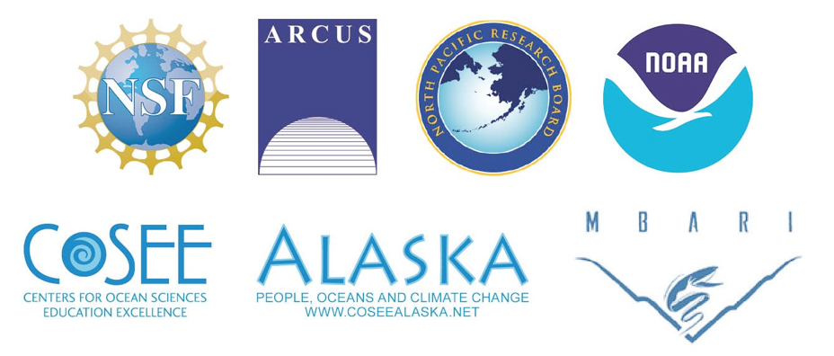
Project Goals & Desired Outcomes
Our goal is to bring together teachers who have been at sea with BEST-BSIERP project researchers, as well as community teachers from the five communities involved in the study (Savoonga, Togiak, St. Paul, Emmonak and Akutan), and other teachers from Bering Sea/Aleutian Islands and Bering Straits region, to interact with each other and project scientists and create a cohesive body of work from their individual activity sets, blogs, journals, videos, and educational resources related to this historic ecosystem study.

Saturday, 9 October 2010
Time | Activity | Who | Technology Needs
All Day | Participants Travel to Anchorage, check in at the Captain Cook Hotel. | All Participants
3:00 PM | Workshop Set Up at NPRB | Workshop Planning Team | Test Technology

Sunday, 10 October 2010
Participants: Make sure to bring your laptop computer with you throughout the workshop.
Time | Activity | Who | Technology Needs
9:00 AM | Breakfast Meeting (Snow City Café) | Workshop Planning Team
10:00 – 11:00 AM | Set Up at NPRB | Workshop Planning Team
10:50 AM | Meet in Captain Cook Lobby to walk to NPRB
11:00 – 12:00 PM | Lunch (Provided) | All Participants
Introduction and Overview
12:00 – 12:30 PM | Introduction & Welcome  - Participant Introductions  - Agenda for week  - Housekeeping items  - NPRB Safety Briefing (Nora) | Janet Warburton, ARCUS | None
12:30 – 1:00 PM | Outline of Workshop Goals and Objectives | George Matsumoto, MBARI | LCD Projector
1:00 – 1:30 PM | Opening Remarks  - Who are we?  - What brought these groups together?  - What are the desired outcomes of the workshop? | Nora Deans, NPRB | LCD Projector
1:30 – 2:00 PM | Icebreaker Activity | George Matsumoto, MBARI | None
2:00 – 2:15 PM | Workshop Evaluation | Andrea Anderson, Soundview Evaluation
2:15 – 2:45 PM | Overview of Existing Resources  - Results of Bering Sea learning resources literature review conducted by NPRB | Nora Deans, NPRB & Marilyn Sigman, COSEE Alaska | None
2:45 – 3:00 PM | Break
3:00 – 3:30 PM | Lesson Plans  - Introduction to the template  - After the workshop | Kristin Timm, ARCUS | LCD Projector
3:30 – 4:00 PM | Standards Overview  - National Science Standards  - Alaska State Standards  - Ocean & Climate Literacy Standards | Marilyn Sigman, COSEE Alaska | None
4:00 – 4:45 PM | Group Discussion  - What are your needs and expectations? | George Matsumoto, Monterey Bay Aquarium Research Institute | None
4:45 – 5:00 PM | Evaluation | George Matsumoto & Andrea Anderson
5:00 PM | Adjourn
6:15 PM | Meet in Captain Cook Lobby to walk to Snow Goose Restaurant
6:30 PM | Group Dinner: Snow Goose Restaurant | All Participants
Monday, 11 October 2010
Participants: Bring materials for presenting your classroom activity, lesson, or demonstration, including presentation slides if applicable.
Time | Activity | Who | Technology Needs
7:00 – 8:00 AM | Breakfast (Provided) | All Participants
8:00 – 8:15 AM | Introduction & Welcome  - Plan of the Day  - Introduction of new participants  - Housekeeping items | Janet Warburton, ARCUS | None
Science Content Presentations
8:15 – 8:50 AM | Essential Questions & Hypotheses of the Bering Sea Ecosystem Study | Mike Sigler, NOAA  Rodger Harvey, University of Maryland | Presenting Via XXXX
8:50 – 9:30 AM | Science Presentation:  Bering Sea Ecosystem Study - Big Picture Overview | Francis Weise, NPRB | Presenting In-Person
9:30 – 10:00 AM | Group Discussion:  - Bering Sea as a system  - Climate induced change  - Why location matters | All Participants | Discussion Via XXXX
10:00 – 10:15 AM | Break
Teacher Presentations
10:15 – 11:30 AM | Teacher Presentations: (5)  10:15: Deanna Wheeler – Lesson Name  10:30: Simone Welch – Plankton Parade  10:45: Maggie Prevenas – “One Ocean One Earth” Project  11:00: Tonia Kushin – Graphing and Spreadsheets with Real Life Data  11:15: Discussion and Questions |  | Presenting In-Person
Science Content Presentations
11:30 – 12:00 PM | Science Presentation: Circulation Over the Bering Sea Shelf | Seth Danielson, University of Alaska Fairbanks | Presenting In-Person
12:00 – 1:00 PM | Lunch (Provided) | All Participants
1:00 – 2:00 PM | Group Discussion:  - Ocean currents  - Stratification and circulation  - Oceanography of the Bering Sea | All Participants
Teacher Presentations
2:00 – 2:45 PM | Teacher Presentations: (3)  2:00: Samantha Dassler-Barlow - A Bering Sea Food Web  2:15: Todd Hindman – ALISON Project  2:30: Paul Lukosi – Lesson Name |  | Presenting In-Person
2:45 – 3:00 PM | Break
3:00 – 3:15 PM | Teacher Presentations: (1)  3:00: Tom Harten – Lesson Name |  | Presenting via Wimba
Science Content Presentations
3:15 – 3:45 PM | Science Presentation: Phosphate Cycling in the Bering Sea Sediments | Emily Davenport, University of Georgia | Presenting In-Person
3:45 – 4:15 PM | Science Presentation: Plankton Ecology and Biogeochemistry | Ray Sambrotto, Columbia University | Presenting via Wimba
4:15 – 5:00 PM | Group Discussion:  - What kind of organisms are responsible for Bering Sea productivity?  - What nutrients are required for marine productivity?  - How are various ocean production regimes connected?  - What is the role of benthic organisms in phosphate cycling? | All Participants | Discussion via Wimba
5:00– 5:15 PM | Evaluation | George Matsumoto & Andrea Anderson
5:15 PM | Adjourn
6:00 PM | Meet in Captain Cook Lobby to walk to Sack’s Cafe
6:15 PM | Group Dinner: Sacks Café and Restaurant
Tuesday, 12 October 2010
Participants: Bring materials for presenting your classroom activity, lesson, or demonstration, including presentation slides if applicable.
Time | Activity | Who | Technology Needs
7:00 – 8:00 AM | Breakfast (Provided) | All Participants
8:00 – 8:15 AM | Introduction & Welcome  - Plan of the Day  - Introduction to new participants  - Housekeeping items | Janet Warburton, ARCUS | None
Teacher Presentations
8:15 – 8:45 AM | Teacher Presentations (2)  8:15: John Karavias – Lesson Name  8:30: Jillian Worssam - Bering Sea to AZ: Microscopic Plants and Animals |  | Presenting Via Wimba
Science Content Presentations
8:45 – 9:15 AM | Science Presentation: Sea Ice and Biological Communities | Rolf Gradinger, University of Alaska Fairbanks | Presenting Via XXXX
9:15 – 10:00 AM | Group Discussion:  - Seasonal Sea Ice  - Ice Algae | All Participants
10:00 – 10:15 AM | Break
10:15 – 10:45 AM | Science Presentation: Sea Birds | Tom Van Pelt | Presenting In-Person
10:45 – 11:15 AM | Science Presentation: Marine Mammals | Andrew Trites, University of British Columbia | Presenting Via XXXX
11:15 – 12:00 PM | Group Discussion:  - Higher trophic levels  - Patch dynamics | All Participants
12:00 – 1:00 PM | Lunch (Provided) | All Participants
Science Content Presentations
1:00 – 1:30 PM | Science Presentation: Modeling the Impacts of the Future Climate on the Bering Sea | Nick Bond, University of Washington | Presenting In-Person
1:30 – 2:15 PM | Group Discussion:  - What can modeling tell us  - Climate predictions  - Future scenarios for the system | All Participants
2:15 – 2:30 PM | Evaluation | George Matsumoto & Andrea Anderson
2:30 – 3:00 PM | Adjourn and meet in Captain Cook Lobby at 2:45 PM for walk to Anchorage Museum | All Participants
3:00 – 6:00 PM | Field Trip: Anchorage Museum  - Museum Exhibits  - Tour of Arctic Studies Center Gallery  - Educational Opportunities at the Museum | Aron Crowell &  Monica Garcia, Anchorage Museum
6:00 PM | Dinner: On Own

Wednesday, 13 October 2010
Time | Activity | Who | Technology Needs
7:00 – 8:00 AM | Breakfast (Provided) | All Participants
8:00 – 8:15 AM | Introduction & Welcome  - Plan of the Day  - Introduction to new participants  - Housekeeping items | Janet Warburton, ARCUS | None
Science Content Presentations
8:15 – 8:45 AM | Science Presentation: Local and Traditional Knowledge in the Bering Sea Project | Henry Huntington, Huntington Consulting | Presenting In-Person
8:45 – 9:30 AM | Group Discussion:  - Do your students see themselves as part of their local ecosystem, or separate from it?  - How does culture influence our perception of the environment? Or our perception of how best to interact with the environment?  - Are there urban/rural differences? | All Participants
9:30 – 10:00 AM | Group Discussion & Recap of All Topics  - Review Major Questions of the Study  - Review of Topics Presented | All Participants
10:00 – 10:15 AM | Break
Learning Resource Planning & Development
10:15 – 11:00 AM | Forming Groups and Picking Topics:  - Matrix of Learning Resources  - Form work groups | All Participants | None
Small Group Work
11:00 – 12:00 PM | Small Group Work  - Work on projects  - Prepare presentation | All Participants | None
12:00 – 1:00 PM | Lunch (Provided) | All Participants
1:00 – 4:45 PM | Small Group Work  - Work on projects  - Prepare presentation  - Break food available as needed | All Participants | None
4:45 – 5:00 PM | Evaluation | George Matsumoto & Andrea Anderson
5:00 PM | Working Dinner: Pizza
5:00 – 7:00 PM | Small Group Work  - Work on projects  - Prepare presentation | All Participants | None
7:00 PM | Adjourn
Thursday, 14 October 2010
Today’s schedule is likely to have more flexibility depending on amount of work time needed and number of teacher presentations; scheduled time to adjourn may vary.
Time | Activity | Who | Technology Needs
7:00 – 8:00 AM | Breakfast (Provided)
8:00 – 8:15 AM | Introduction & Welcome  - Plan of the Day  - Introduction to new participants  - Housekeeping items | Janet Warburton, ARCUS | None
Small Group Work
8:15 – 11:30 AM | Small Group Work  - Work on projects  - Prepare presentation  - Evaluation activity | All Participants | None
11:30 – 12:00 PM | Learning Resources - Next Steps  - Review Process  - Where they will live | Kristin Timm, ARCUS | None
12:00 – 1:00 PM | Lunch (Provided) | All Participants
During lunch, participants should upload final lesson plans in templates to FTP site and prepare for afternoon presentations.

1:00 – 3:00 PM | Teacher Presentations | All Participants
3:00 – 3:30 PM | Wrap Up Discussion
3:30 – 4:00 PM | Evaluation | George Matsumoto & Andrea Anderson
4:00 PM | Adjourn
 | Dinner (On Own)
4:00 – 6:00 PM | Meeting Room Deconstruction, Clean Up, and Packing | Workshop Planning Team
3:00 – 9:00 PM | Optional Activity: Free Admission Night at the Museum

Social Networking Form
Topic of conversation:
Topic of conversation:
My name:

My organization:
Name:
Organization:
Name:
Organization:
Name:
Organization:
Name:
Organization:
Name:
Organization:
Name:
Organization:
Topic of conversation:
Topic of conversation:
Topic of conversation:
Topic of conversation:

Teacher presentations will be 10 minutes with 5 minutes for transition and questions.
Teacher presentations will be about 20-30 minutes per group or individual.

